Getting Started with Boku
Revised Monday, November 17, 2008

The parts of the Xbox 360 Controller 2
Load a World 3
The Main Screen 3
The Load Screen 3
Sorting the world list 4
use tags to filter the world list 4
navigating within a world 5
Standard Navigation Controls 5
Add objects to the world 6
The Tool palette 6
Add an apple to the world 7
Add a character to the world 7
getting help on individual objects 8
Moving and reorienting characters 9
create a very basic program 10
Activate the Object Tool and create a boku 10
Open the program editor 10
The simplest possible program: “just move” 11
deciding when to do something 12
change “move always” to “move when you see something” 12
“move forward when you see something green” 13
More examples 13
Getting help while programming 14
landscaping: moving ground up or down 15
The Up/Down Tool 15
creating new terrain 16
the add/remove ground tool 16
Choosing Terrain Type 17
adding water to your world 18
Make Lakes and Rivers 18
Lesson 7 – How to make Flat Areas 19
Pick the flatten tool 19
Make Flat Areas 19
Lesson 8 – How to make Rough or Curvy Ground 20
Load the WOrld 20
Activate Rough or Curvy Tool 20
Make Rough or Curvy Ground 20
For Further Exploration 20

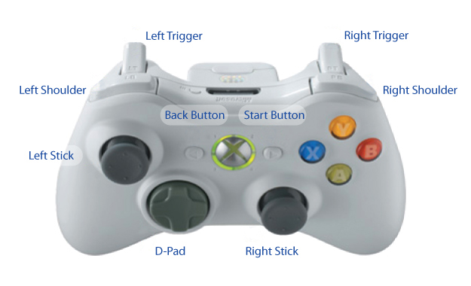
The parts of the Xbox 360 Controller

Load a World

The Main Screen
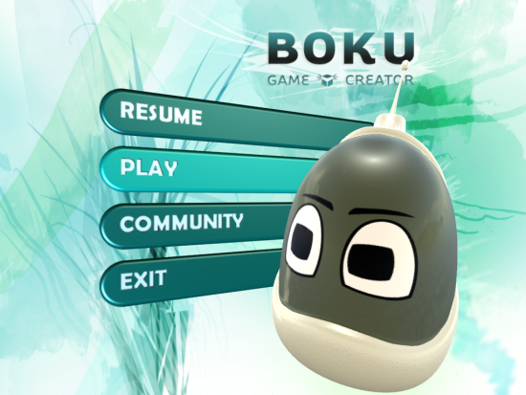
The Main screen provides four options:
- Resume: open whatever level I last edited
- Play: load a level from the hard drive
- Community: download levels from the Internet
- Exit
We’re going to load a level from the local hard drive. Use the left stick on your controller to select Play and press the button.

The Load Screen
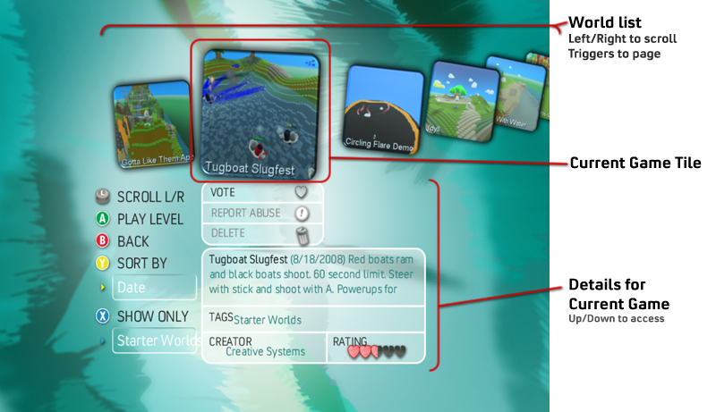
The load screen shows eight games at a time. You can move back and forth within these games using the right stick. To see the next page of games, press the right trigger. To launch a game, press the button.
There are additional controls below the currently selected game picture that allow you to provide feedback on a level or delete it. To access these controls, move the left stick up and down.

Details for each game are below the current game tile. You can read the summary of the game, and you can delete the game or provide feedback. Move the stick up and down to access the details. Move up to reselect the current game tile so that you can launch the game.

Sorting the world list
You can sort worlds by date, author, title, or rating. This can make it easier to find a world created by your friend or created on a certain day. Press the button to open the sort menu. Use the left stick to select different menu items and press to sort.
To close the sort menu without sorting, press the button.

use tags to filter the world list
Sometimes the list of worlds is long and you want to focus on a shorter list. Enter the tag menu. Each world may have several tags. Tags indicate, among other things, the type of game (racing, shooter, puzzle, etc.)
To show only worlds having a given tag, press the X button to open the tag menu. Select a particular tag using the left stick, and press A to choose that tag. The list of worlds will now show only worlds that have that tag.
Some of the tags have special meanings:
- My Worlds – Worlds created or edited by you - anything you’ve saved
- Starter Worlds – Games already created with minimal functionality
- Downloads – Worlds Downloaded from the Community

navigating within a world
Let’s look at a very basic world so that we can learn how to move around and activate different modes.
- Open the load screen.
- Use the tag menu to show only worlds tagged with Lessons.
- Open the world Boku and Tree.
You should see a very simple world with a small robot (Boku) and a tree.
Cursor
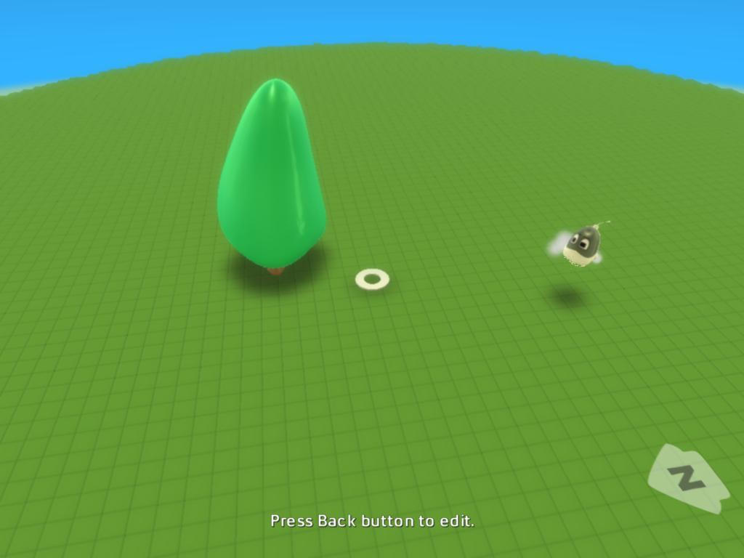
When you open the level, it is in “play mode.” Since this is such a simple world, there is no gameplay, but you can look around.

Standard Navigation Controls
The small white circle in the middle of the screen is your cursor. Later we’ll use the cursor to edit the world, but now we’ll just drive around to look at the world using the following standard controls:
- Move the cursor using the left stick
- Change the camera angle using the right stick. The camera will remain pointing at the cursor.
- Zoom in and out using the shoulder buttons (see the diagram of the XBox controller above)
Try driving around a bit now to get a feel for it.

Add objects to the world

The Tool palette
When you first launch a world, you are in Play Mode. When you want to edit the world, you need to choose an editing tool from the Tool palette.
Open the world we used on the previous lesson: “Boku and Tree.” The world will open in play mode.
Now open the tool palette by pressing the start button on the XBox 360 Controller. The start button is to the right of the silver medallion in the center of the controller.
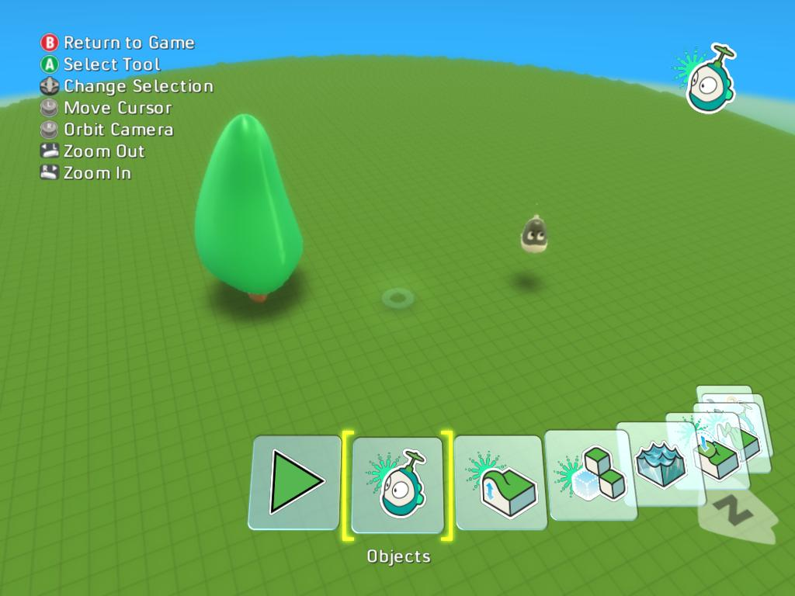
Current Tool
Tool Palette
Selected Tool
The tool palette at the bottom of the screen lets you choose a new tool. Use the triggers or the d-pad to move the tool palette back and forth. To activate the currently selected tool, press the button.
The icon in the upper-right hand corner shows you what tool you currently have selected. This will remain on the screen after you have closed the tool palette.
Try moving the tool palette back and forth with the triggers. Then select the Objects tool and press to make it active.
With the object tool active, move it around the world with the left stick. Notice that when you put the cursor on a character or other object, both the cursor and the object glow blue.

Add an apple to the world
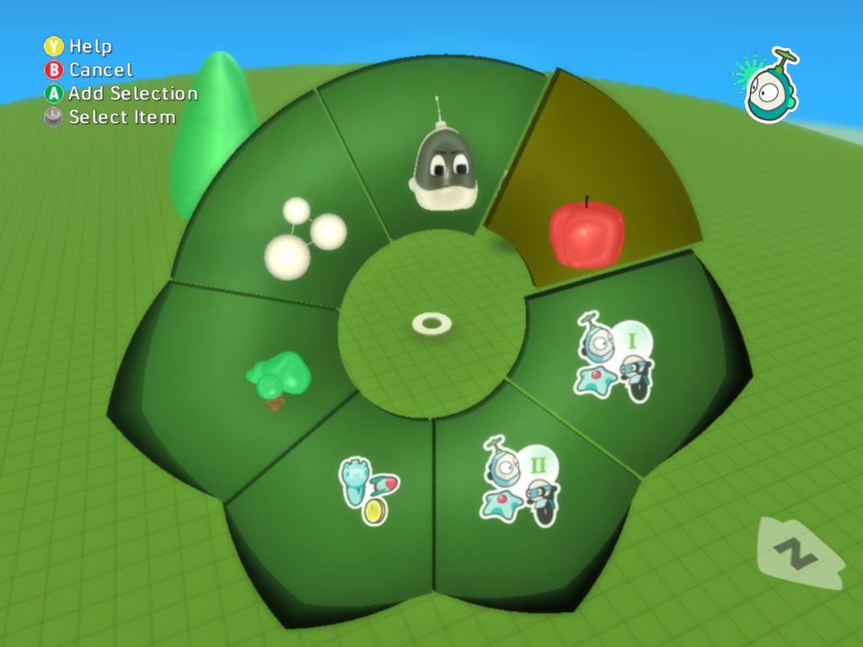
The object tool should now be active (check the upper-right corner for a “robot” icon) and the tool palette should be closed. If the wrong icon is showing - or no icon - press the start button to open the tool palette again and choose the object tool.
Navigate the cursor to a place in the world where you would like to place an object. Press to open the Add Object Menu (right.)
You navigate the Add Object menu with the left stick. The highlighted item will glow yellow and pulse.
Select the apple in the upper-right area of the menu (right) and press to add an apple to the scene. The apple will appear at the location of your cursor.
Since your cursor is on the apple, both will glow blue. If you move your cursor away it will stop glowing.
Some of the items in the Add Object Menu - such as the tree - will open smaller menus.

Add a character to the world
Let’s add another object:
- Move the cursor to a clear place in the world
- Press to open the Add Object menu
- Select the icon with the robots and the letter “I” on it (right)
- Press on this icon will open another menu (below, right.) This menu allows you to pick a specific character.
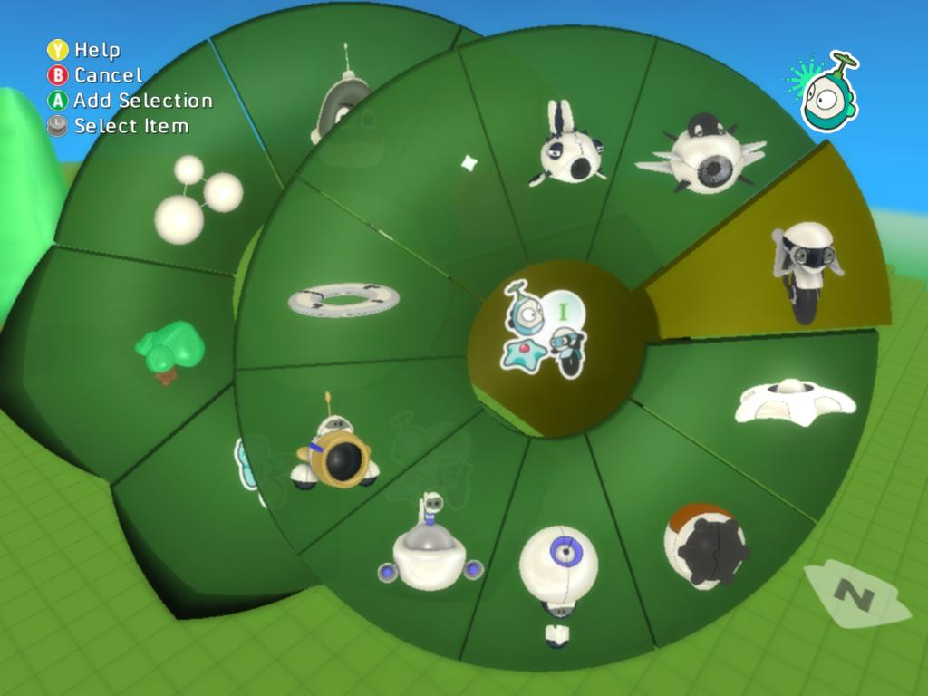
NOTE: this is an example of a group menu. Group menus are used to organize the menu items so they are easier to navigate. You can identify a group menu because it has a point on it (above right)
- Select the Mobiko character (highlighted at right)
- Press to insert the Mobiko character into your world.

getting help on individual objects
Boku provides interactive help for all the characters and objects. If you’re not sure what a character does, or you want to see examples of a how you can use it, you can open the Help to read about the character and pick from a library of examples featuring that character.
Whenever the Add Menu is open (below,) you can press to get help on the currently selected character.
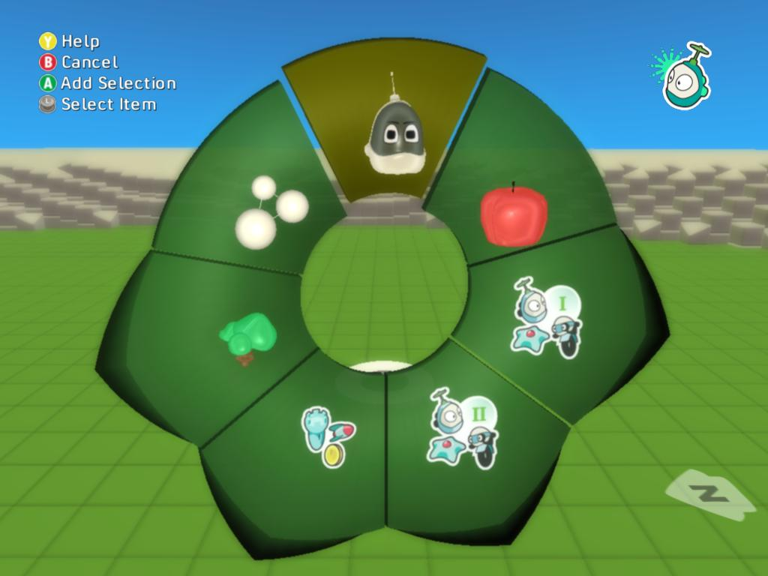
- Choose the character tool:
  - Press the back button to open the tool palette
  - Use the triggers to select the object tool
  - Press to activate the object tool
- Move the cursor to a place where you’d like to put a character
- Press to open the Add Object menu (right)
- Navigate within the Add Object Menu to find a character or object you’d like help for
- With that menu item active (don’t insert the character yet,) press to open the help for that character
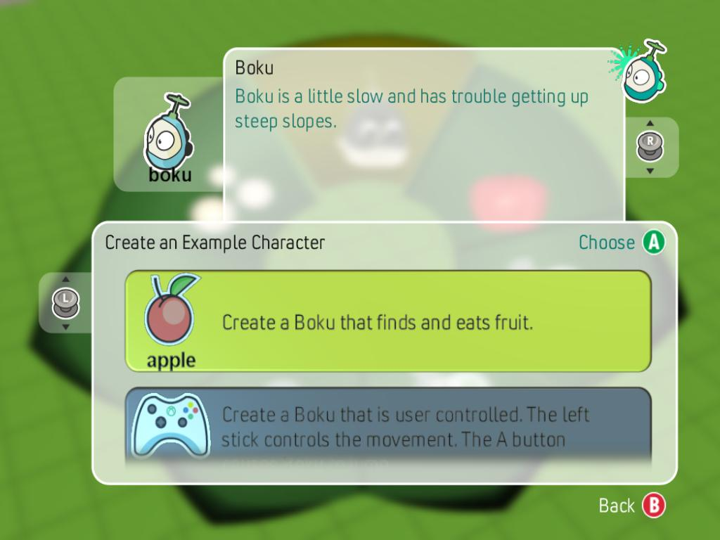

Moving and reorienting characters
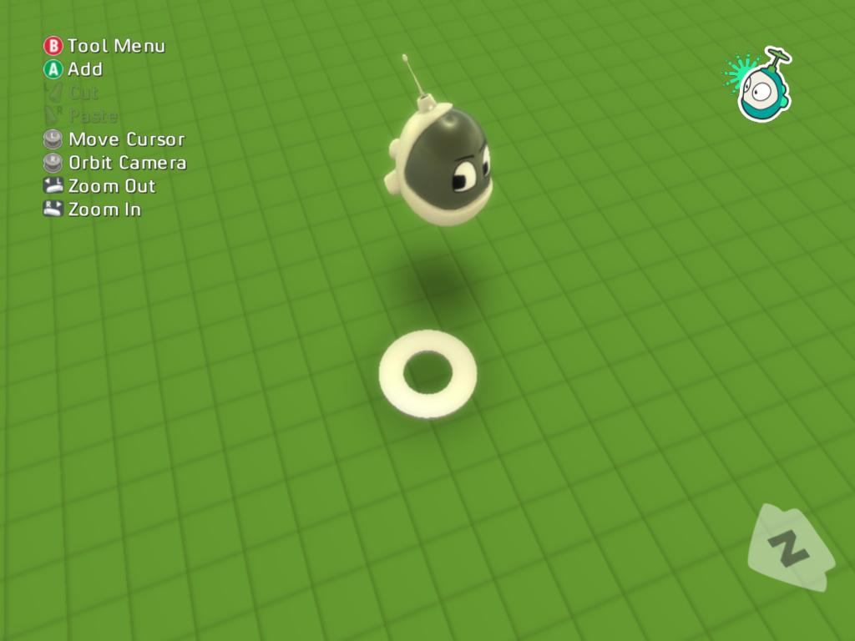
It’s common to create a character in one position and then realize that he would work better somewhere else. It’s also common to want to change which direction a character is facing. For both of these, it is useful to understand the different selection states that a character may be in: unselected, selected, and active.
Moving characters is easy.
- Select the Object tool. If you don’t have a character in the scene, add one now..
- Move the cursor under the character that you want to move. The character should change from its unselected color (above right) to its active color blue (middle right.)
- Press to pick up the character. It should change to red - the selected color (below right)
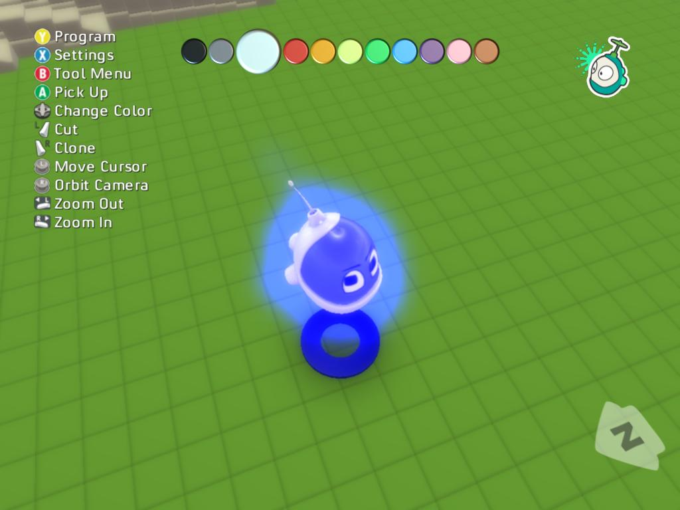
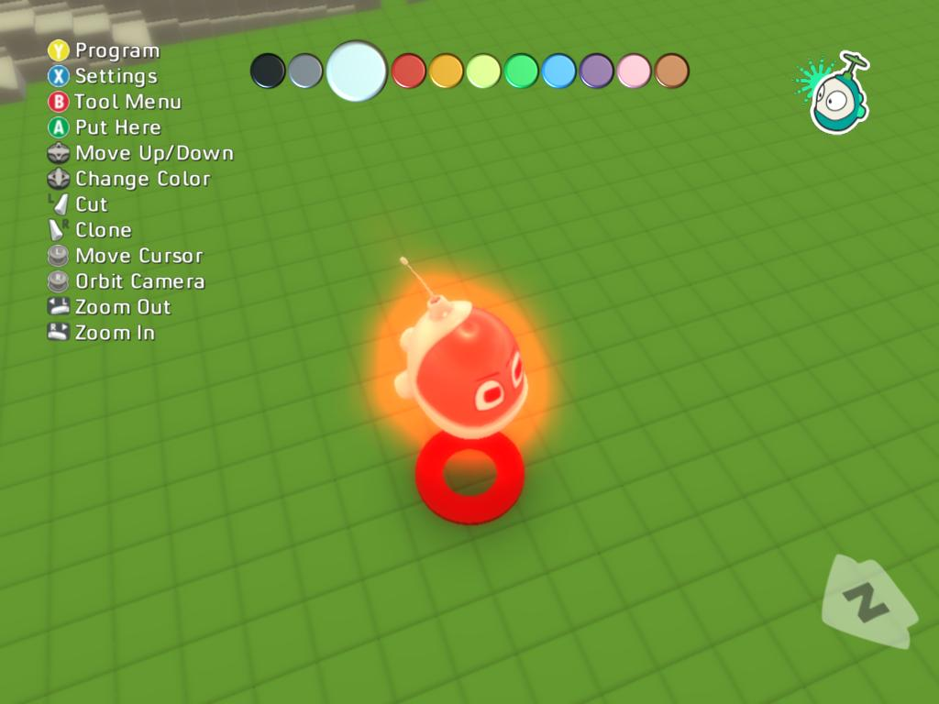
When a character is selected (red,) it “sticks” to the cursor. You can move it around with the left stick and rotate it with right stick.
Try moving the character around and reorienting it.
When you have the character where you want it, press to deselect it. It will remain blue until you move the cursor away, but it will no longer stick to the cursor.

NOTE: if you have a lower-end graphics card, you will not see the glow effect on the character - but the cursor will still change color.

create a very basic program
Please open the level “Basic Terrain.” You may also use any other level for this lesson, but it will be easiest if the level you use doesn’t have any other characters in it.

Activate the Object Tool and create a boku
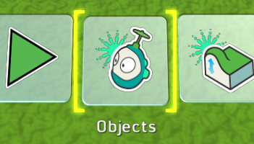
Press the start button to bring up the Tool Menu. Use the triggers to navigate the menu and select the Object tool. Press to activate it.
Now use the character add menu to add a Boku to the scene. If you do not remember how to do this, please see the “Adding Objects” section above.
Keep the object tool active for the next steps. The object tool serves to edit programs as well as adding and removing objects.

Open the program editor
Move the cursor until it is under Boku. He will glow blue. Press the button to open the program editor, like so:
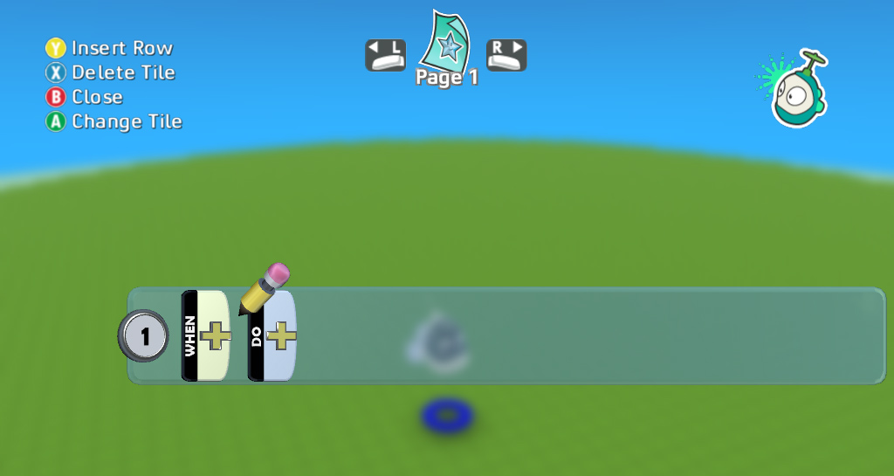
Here we see the program editor showing an empty program or, more precisely, a program consisting of one rule, which does nothing.
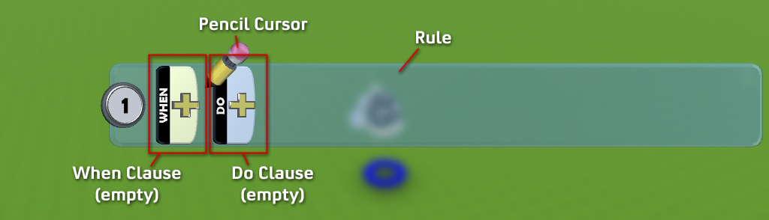
I mentioned that this program contains one rule. A rule tells the bot what to do and when to do it.
The first part of a rule is the When Clause. It says when something is going to happen; the condition that will make the bot react. You can say things like ‘when I see something red’ or ‘when I bump into a tree’ or even ‘when 2 seconds have passed.’
The second part of the rule is the Do Clause. It specifies what the actor should do when the ‘when part’ activates or ‘fires’. Bots can do all kinds of things, such as shoot, move, or eat. Different bots have different capabilities.
The plus sign in the rule lets you add more elements to the rule. We’ll talk more about that in a later section.

The simplest possible program: “just move”
Use the left stick on the controller to move the pencil cursor over so it points at the plus sign in the Do Clause (see right.)
Press the button and you should see the Verb Menu (below right.) This menu shows different things this bot can do.
Use the left stick to highlight the move verb, and press to insert it into your program. Your program should now look like the picture on the bottom right.
The verb menu lets you specify what the bot is going to do when this rule activates. Since we haven’t said when the rule should activate, it will be active all the time.
In effect, what our program says is “always move.”
Since we didn’t say which direction or how to move, the bot will pick a direction.
To run your program, press the button repeatedly; this will close the programming UI, return to the tool menu, and then return to play mode. You should see your Boku move in a straight line.

deciding when to do something
This lesson builds on the previous one. If you haven’t done it, please do it now.
Press the start button to bring up the Tool Menu. Use the triggers to navigate the menu and select the Object tool. Press to activate it.
Now use the Character Add menu to add a Boku to the scene. If you don’t remember how to do this, please see Add objects to the world.

change “move always” to “move when you see something”
Your scene should have one Boku, and his program should look like this. (Reminder: to see a character’s program, use the Object tool, move the cursor under the character (so that both glow blue) and press the button.
This program says “move no matter what.” We want to change it to say “when you see anything, move.”
- Move the pencil to the first part of the rule
- Press to open the Sensor menu (below right)
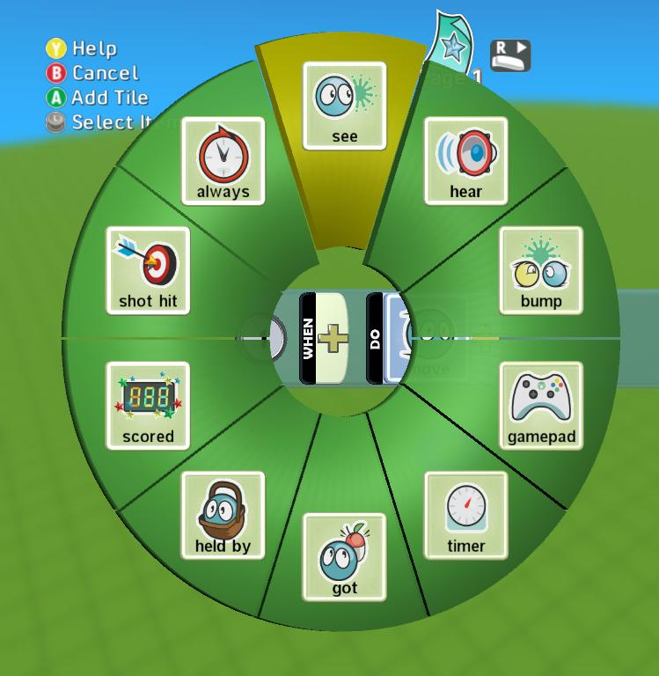
This shows you things that the bot can react to: he can react to things he sees, hears, or touches, and so on.
- Choose see from the sensor menu (right)
- Press to insert it in the menu.
- Your program should look like this:
Go ahead and try your program now. Press to close the program editor, and press the start button to run the program.
If you run this program in an empty world, Boku will not move, because he cannot see anything. If there are no objects in the world, use the Add menu to add an apple, tree, or anything else. Note that the ground and sky don’t count as objects.

“move forward when you see something green”
We’d like to change our program so that Boku only moves when he sees something green. To do this, we will add to the When part of the rule. Open the program editor and put the pencil just after “See” tile. (see right)
Press the button, and you should see the below menu. Since you already have a see sensor in your program, opening the menu after this sensor gives you options for modifying the see operation. You don’t usually have to think about this; as you build a program, the menus will change to show the right options automatically.
Let’s make our boku respond only to green objects:
- Use the left stick to select the colors group (right)
- Press to open it
- Use the left stick to select green
- Press to insert green into your program
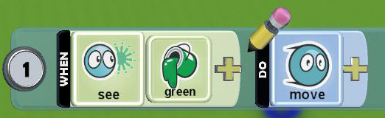
Your program should now look like the below. It means “when you see anything green, move.”

More examples
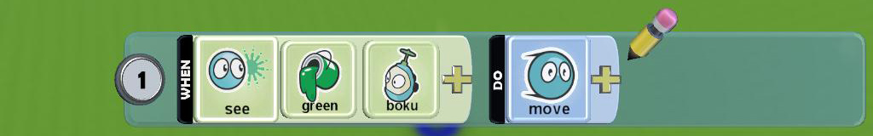
If you see a green boku, move.
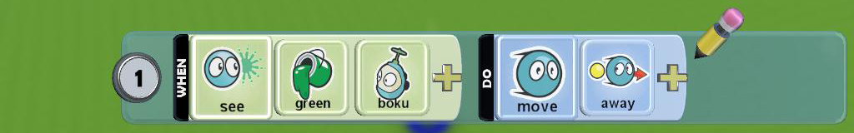
If you see a green boku, move away from it.

Getting help while programming
The program editor provides help for all the programming tiles. Whenever you are looking at a tile in the tile selector menu, you can press to get help on that specific tile. The help system will also show you help for the other tiles in your program. You can also find related examples related to your program that you can easily insert into your program.
- Select a character and press the button to open the program editor (right)
- Enter the program shown (or any program)

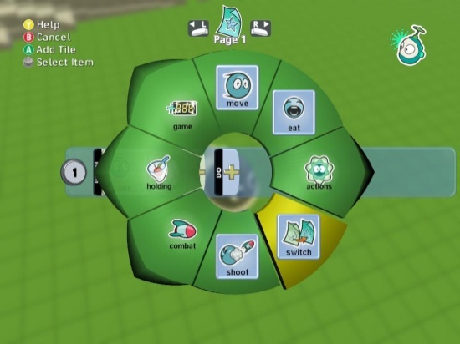
- With a selector menu open and a tile selected (below right) press the button for help on the selected tile
- The help for the selected tile will be displayed
- Note that the other tiles in your current row (see and boku in the below picture) will also appear at the top of the help screen. You can see help for those tiles by moving the left stick left and right.
- Examples related to your program are shown below. Move the stick up and down to select an example and press to insert the code into your program
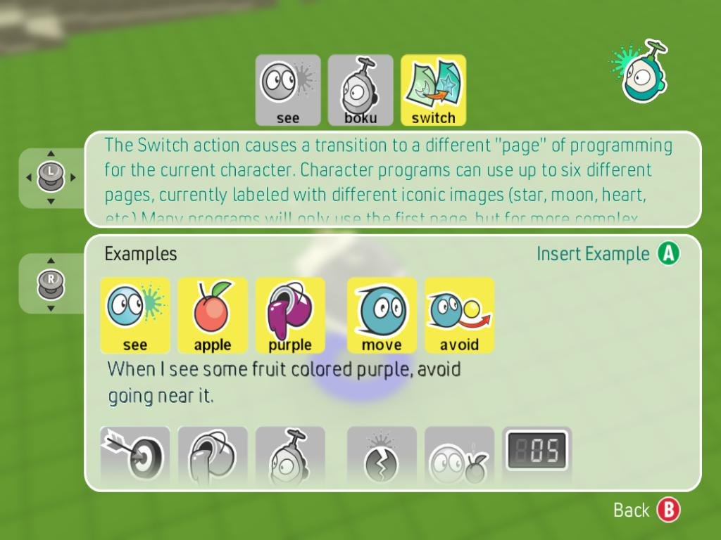

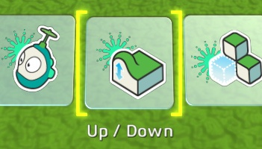
landscaping: moving ground up or down
Making hills and valleys is fun, easy, and allows you to set up interesting game mechanics. The shape of the ground affects character behavior: hills block vision, and some characters can’t climb steep hills.
Use the Load screen to browse to the Lessons tag. From that group of Worlds, choose the one called “Basic Terrain.” You can also adapt this lesson to many of the other levels.

The Up/Down Tool
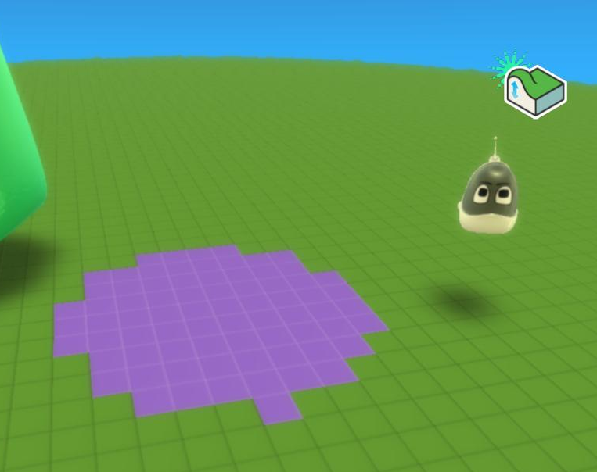
Press the start button to open the Tool menu. Use the triggers to move the Tool menu back and forth. Select the Up/Down tool and press to activate it.
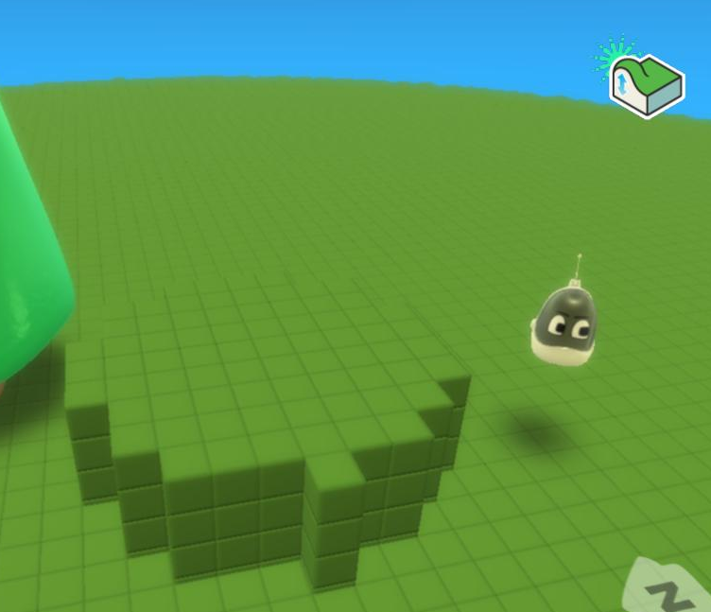
You will see a flashing area on your terrain. It’s purple in the picture at right but the color depends on the terrain. This is your brush; it shows which part of the ground the tool will affect. Most of the tools that affect terrain work like this. You can change the size of the brush by moving the D-pad () left or right.
Position your brush in an empty area. Pull the right trigger briefly and release it. You should see the area beneath the brush rise to form a small plateau (below right)
Now try holding the right trigger down while you move the brush using the left stick. You can “paint” long hills and valleys this way.
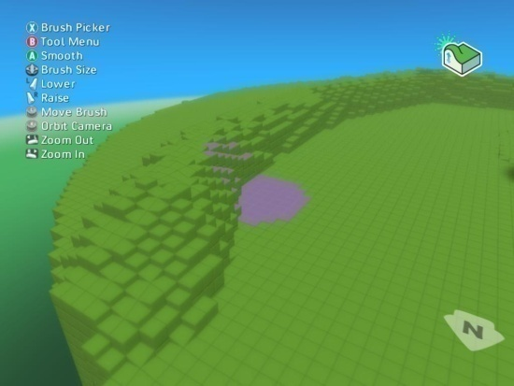
You can also move the brush while you are raising or lowering the ground. Try holding the right or left trigger while moving the left stick - with practice you can paint mountain ranges and hills.
Brushes come in many shapes. Press the button to open the brush menu. Use the triggers to move back and forth in the brush menu and press the button to select a brush. Some of the brushes have different shapes and some of them work very differently. Play around with different brushes to see how they work.

creating new terrain
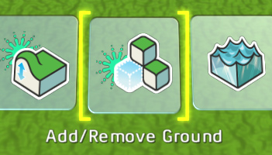
Boku includes several stock worlds for you to use, but sometimes you need a custom shape to make the game you want. Using the Add tool, you can make worlds of many different sizes and shapes. The shape of the world is very important to game design and can make simple game programs much more interesting.
For this lesson, please open the Basic Terrain level from Lessons.

the add/remove ground tool
Press the start button to bring up the Tool Menu. This will pause the game. Use the triggers to move the Tool Menu back and forth. Select the Add/Remove Ground tool, press to activate it.
You will see a flashing square on your terrain. This is your brush; this shows which part of the ground the tool will affect. You can change the size by moving the D-pad () left or right.
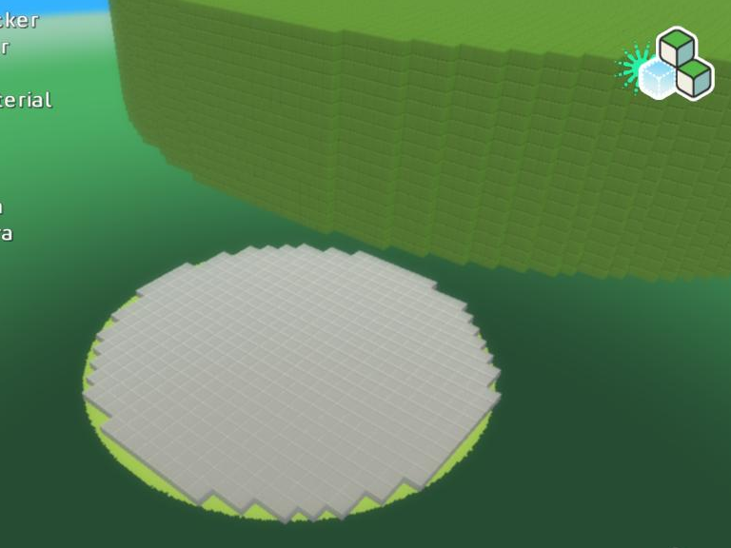
Let’s get started:
- Move the brush off the terrain. You may want to zoom out using the shoulder buttons. (above right)
- Adjust the size of the brush with the D-Pad
- Pull the right trigger briefly
- Notice that you have create a new island
You can hold down the trigger while moving the left stick to continue adding terrain in a line.
Deleting terrain is just as easy:
- Position your brush so that it overlaps existing terrain
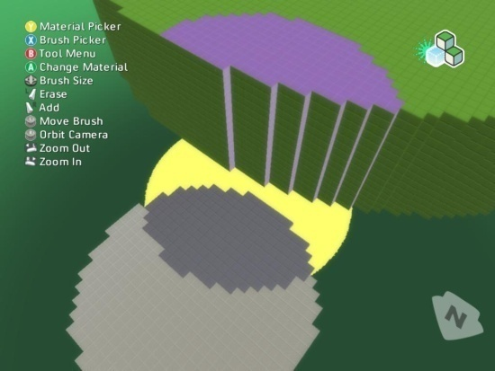
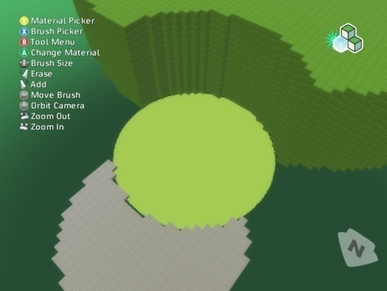
- Pull the left trigger

Choosing Terrain Type
Boku includes many different building blocks for your terrain; we call these blocks materials. Let’s pick a different material and using it to extend the world.
- Press the button to open the Material Picker (right)
- A list of cubes will appear
- Scroll back and forth in this list using the shoulder buttons
- Pick a material with the button
Now that you have chosen a new material, create some more terrain using this material
- Use the left shoulder to zoom out a bit
- Hold down the right trigger
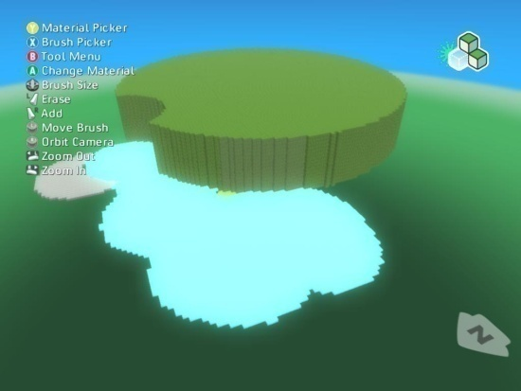
- Move the left stick to paint new terrain

adding water to your world
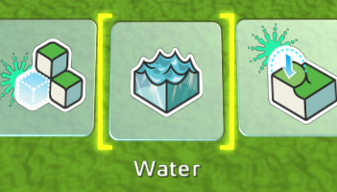
When you add water to a world, it is as though you are pouring the water onto the ground at a particular point; the water will pool in low-lying areas to form lakes and streams.
- Use the Load screen to browse to the Lessons tag. From that group of worlds, choose the one called “Water World”.
Press the start button to bring up the Tool Menu. Use the triggers to navigate the menu and select the “Add or Remove Lakes and Rivers” tool. Press to activate it.

Make Lakes and Rivers
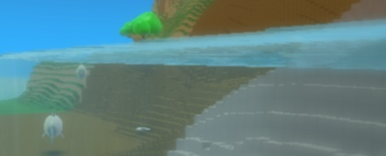
Choose a spot to pour water onto the ground. Press the right trigger to add water at the cursor and the left trigger to remove (lower) the water. Use this tool by moving the cursor anywhere where you want the water to rise or sink. Different bodies of water can have different types. If two bodies of water touch, they will take on the same appearance.
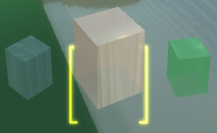
Use the left trigger to lower the Water and the right trigger to raise it. Notice how the water follows the shape of the terrain, pooling in lower areas and stopping at higher areas.
There are different types of water. To change the type you are creating, press to open the water menu. Use the triggers to move back and forth in this menu, and press when you've selected the type you want to use. This type will apply to any new water that you create. To change existing water to use this type, move the cursor over that water and press the button to set the type of that water.

Lesson 7 – How to make Flat Areas
You will often find that you need a flat “arena” in which your gameplay can happen. The flattening tool makes it easy to level an area to a consistent height.
Use the Load screen to browse to the Lessons tag. From that group of worlds, choose the one called “Flat Land”

Pick the flatten tool
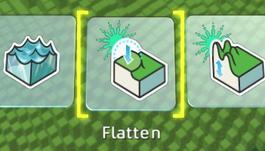
Press the start button to bring up the Tool Menu. Use the triggers to navigate the menu and select the “Create Flat Areas and Ramps” tool. Press to activate it. You will see a flashing area on your terrain. This is your brush; this shows which part of the ground the tool will affect. You can change the size by moving the D-pad () left or right.

Make Flat Areas
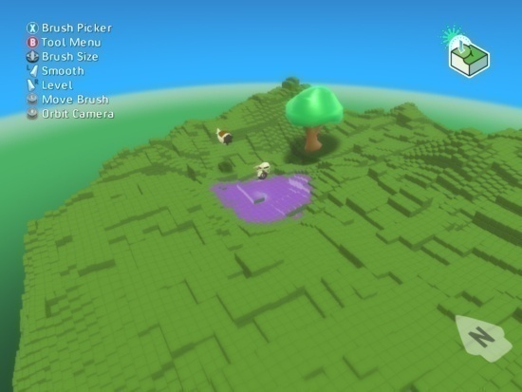
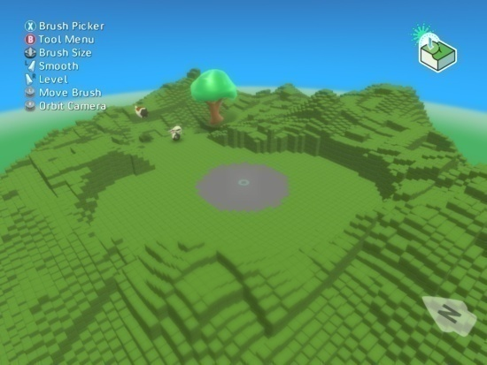
When you paint with the flattening tool, it looks at the height where you start painting and then raises (or lowers) everything the brush touches to that same height. If you start at a mountain peak and drag the brush across the terrain, you will create a flat area at the height of that peak. If you start in a deep valley, the brush will lower ground to that level.
Move the cursor to the location where you would like to start flattening. Pull the right trigger to start flattening and hold it down while you use the right stick to paint a flat area. Notice that ground is lowered or raised as the brush touches it to reach the desired height.
If you want to change the brush you are smoothing and leveling with press the button and select the brush you want, using the Triggers. Press the button to accept.

Lesson 8 – How to make Rough or Curvy Ground
The Roughen tool randomly changes the height of the terrain under the brush. It has two variants: spiky creates truly random, spiky effects, and hilly creates a more rounded, softer look.

Load the WOrld
Use the Load screen to browse to the Lessons tag. From that group of worlds, choose the one called “Rough Terrain”

Activate Rough or Curvy Tool
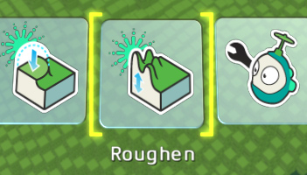
Press the start button to bring up the Tool Menu. Use the triggers to navigate the menu and select the Roughen tool. Press to activate it. You will see a flashing area on your terrain. This is your brush; this shows which part of the ground the tool will affect. You can change the size by moving the D-pad () left or right.

Make Rough or Curvy Ground
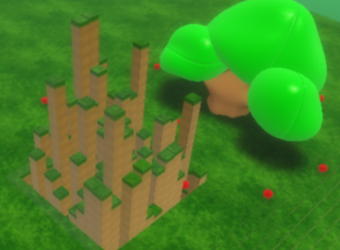
Use the left trigger to spike the terrain and the right trigger to make the terrain hilly. While you could do this with the up/down tool and a very small brush, this tool makes it easier to add visual detail over a large area.
If an area gets to spiky, you can smooth the terrain under the brush by pressing the button.
If you want to use a different brush, press the button to open the brush menu. Use the triggers to move through the brush menu and press the button to accept your brush selection.

For Further Exploration
Try using the rough/curvy tool to create different visual effects: Create an ocean with a jagged bottom and a smooth beach. Make a world with a flat area, a smooth hilly area, and spiky mountains. Create a mountainous terrain with a narrow path going through it - perhaps by using the rough/curvy tool together with the flatten tool. Create a world with a mountain and a ramp that lets a character move from the bottom all the way up to the peak of the mountain.

