Computer-Controlled Evacuation of a

Vacuum Chamber

Executive Summary

October 12, 1999

Loren Gordon
Michael Shear

WPI Advisor:
Dr. Fred Looft, Electrical and Computer Engineering Department

NASA Mentors:
Ray Boucarut
Doug Leviton
Tim Madison
Executive Summary
Introduction
This report details the work completed to create a reliable program to control the pump-down process of the vacuum chamber, which is the heart of the Diffraction Grating Evaluation Facility (DGEF) at NASA’s Goddard Space Flight Center. This project was based on an existing system using National Instruments’ graphical programming language “LabVIEW” to monitor and control the system hardware via a Data Acquisition and Control Unit (DA/CU). The major problems with the previously existing program that were fixed during this project were a very slow execution speed and poor error-handling which resulted in less than the required amount of reliability.
The purpose of the Diffraction Grating Evaluation Facility is to provide support for flight projects in the form of world-class optical test facilities. These facilities consist of a class 100,000 clean-room that contains a large vacuum chamber and special equipment for optical measurements. A complex sequence of steps is required for a successful pump-down of the vacuum chamber, which has in the past meant that a skilled technician had to be present at all times when the system was operating.

Problem Statement
This project encompassed three specific tasks. Our first task was to develop a well-tested manual pump-down control program that would work reliably and predictably. Our second task was to expand upon the system by giving it the capability to respond to error conditions during operation and carry out a nominal pump-down in the absence of errors. Our third task was to improve on the existing sensor suite. The two main areas of concern for this latter task were valve position sensors and compressor power status monitoring.

Background

Background of Vacuum Concepts
By definition, a vacuum is a volume of space that contains fewer atoms than a similar volume under normal atmospheric pressure. A vacuum is measured in units of torr, which is equivalent to the pressure exerted by a one-millimeter thick layer of mercury under a gravity field of one Earth normal gravity. Zero torr is a total vacuum, defined as a volume containing no atoms whatsoever, and 760 torr is standard sea level atmospheric pressure.
To create a vacuum, a volume must first be completely sealed. Vacuum pumps can then remove atoms to create a vacuum in that volume. There are several types of vacuum pumps, with each type having its own specific method of removing atoms. Two types of pumps are used in the DGEF; these are called positive displacement pumps and entrapment pumps. A positive displacement pump seals off a volume of air and forces that air out of the vacuum chamber. This type of pump is most effective for rough vacuums, and usually has a lowest achievable pressure of around 10⁻² torr. An entrapment pump works by capturing molecules; in the case of the “cryopumps” used by the DGEF, the capture method is to freeze molecules onto an ultra cold (10 degrees Kelvin) cryohead. This method works best at high vacuum levels when there are fewer particles than in rough and medium vacuums; if there are too many particles to absorb, the pump “fills up” too quickly and cannot absorb any more. Entrapment pumps can achieve vacuums of 10⁻⁵ torr or better, and the DGEF uses four of these types of cryopumps to complete the pump down that the single mechanical roughing pump begins.
The vacuum chamber in the DGEF is a 20 by 10-foot rectangular chamber inside a class 100,000 clean-room. The chamber sits on platform consisting of a thirty-eight ton granite block with a three and a half inch thick aluminum base plate mounted on its surface. An air table supports the platform so that it is isolated from any vibrations that may be present in the rest of the building. A ten-inch collar with forty feed-throughs, which is welded to the rim of the aluminum base plate, provides power and communication for the instruments that are being tested. An eleven-ton cover rests on a platform about ten feet from the vacuum chamber when the chamber is not in use or instrumentation is being prepared. When ready, operators use a twelve-ton crane to lift the cover and place it on top of the chamber where it is held tightly against a sealing O-ring by its own weight. The cover is approximately forty inches in height, which makes the vacuum chamber more than a yard in depth when the cover is mounted on top.

Hardware Configuration
The control program ran on an Intel Pentium-based PC under the Windows 95 operating system. This control computer communicated with the rest of the system primarily through an HP 34970A Data Acquisition and Control Unit (DA/CU) using a General Purpose Interface Bus (GPIB). This type of bus is alternately known as an “IEEE-488” bus or a Hewlett-Packard Interface Bus (HP-IB). Three instruments, the power supply, the vacuum gauge controller, and the constant-current supply, were directly controlled by the computer over the GPIB as well. All other sensing and control functions went through the DA/CU.
The primary sensors used were valve position sensors, compressor power status sensors, flowmeters, vacuum gauges, and temperature sensors. Of these, the compressor power status sensors and valve position sensors were modified in the course of this project. The major controls were valve controls and compressor power controls. There were also some less-used sensors and controls including a power supply voltage sensor to verify that the power supply is operating normally and trap heater controls.

Software Used
LabVIEW (Laboratory Virtual Instruments Engineering Workbench) is a graphical language that is designed for data acquisition and hardware control. LabVIEW makes this control simple with virtual instruments (VIs). These VIs imitate real instruments and are similar to C or C++ functions and subroutines, which results in extremely modular code.

Methodology

Introduction
We began the project by deciding to modify the program created by the contractor Bernard Puc. His program used all of the low-level, driver functions written by the 1997 MQP group, to communicate with the hardware. His approach was very modular; there was one VI to control the hardware, one VI to communicate with the hardware, one VI to log data, and one VI to control the pump-down automatically. All of these VIs communicate with each other through global variables. Our design keeps Bernard Puc’s modular arrangement, but we rearranged the front panel, incorporated many of the features from the 1998 MQP group’s program, and improved the logic of the manual and automatic programs. Once that was complete, we added comprehensive interlocks, modified the compressor power sensing, and replaced the cryo valve sensors.

Front Panel
Our first task was to rearrange the front panel to reflect the actual layout of the vacuum chamber (See Figure 1-1). This rearrangement made the program more intuitive to use and reduced the clutter on the front panel. Doing this first gave us a chance to familiarize ourselves with the program without affecting the program’s operation.
There are two types of items shown on the front panel: controls and indicators. Controls are used to tell the hardware what to do. Indicators display the actual state of the hardware. There are additional buttons that open sub-VIs to provide greater control over the hardware or program operation.
Figure 1-1: Front Panel
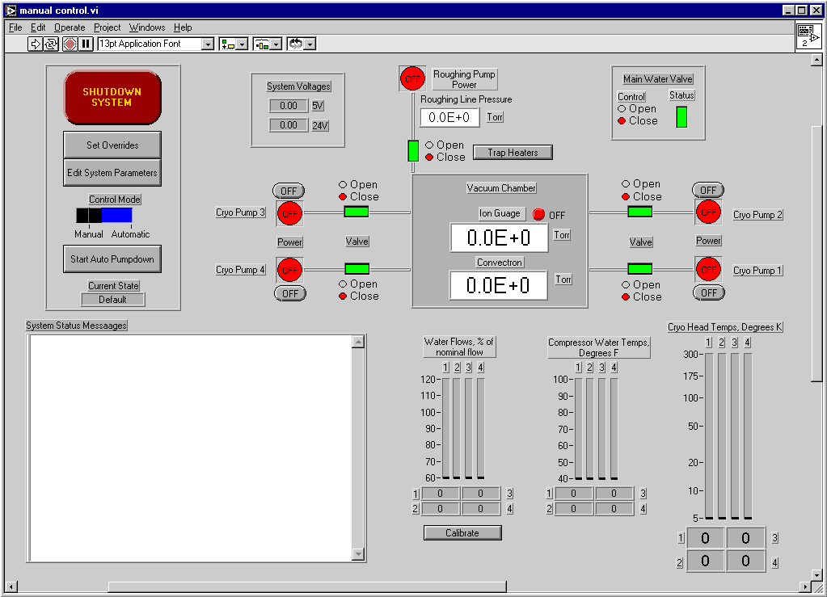

It was decided to rearrange the front panel of the control program to reflect the layout of the vacuum chamber. Thus, a box was placed in the center to represent the vacuum chamber. Inside the box, we placed indicators that display the current chamber pressure. Then we added the four lines off to either side of the box, which represent the cryo pumps. The position and numbering of these lines reflect the position and numbering of the cryo pumps inside the clean room.
The bar graphs were implemented along the bottom to provide the operators with the vital information they need to correctly operate the vacuum chamber. In the top left corner of the front panel, we put all of the controls that affect program operation. The “Shutdown System” button provides the operators with a quick and easy way to shutdown the system from the front panel in either manual or automatic mode.

Manual Program
The manual control program must provide the operator with enough control over all of the hardware necessary to complete a pump-down effectively. In addition, the manual program must allow the operator to monitor anything that could potentially become a problem. The manual LabVIEW program written by Bernard Puc was well designed, but lacked some of the functionality desired by the DGEF staff. For example, the main water valve and trap heaters could not be controlled, nor did the program monitor the flow of water through the compressors. These features were added during the course of the project.
In manual mode, although the user has control over every aspect of the program operation, some actions, such as opening the roughing valve while a cryo valve is open, should never be allowed due to the amount of damage that could occur. Thus, we implemented a system of interlocks to prevent users from completing actions that would be harmful to the vacuum chamber. If the operator must complete the action, these interlocks may be bypassed by overriding the appropriate item using the system overrides.

Automatic Program
The automatic program allows the operator to conduct a pump-down by clicking on a single button and monitoring the program’s operation. There are five states in an automatic pump-down: Default, Roughing, Low Vacuum, High Vacuum, and Shutdown. We designed the automatic program to control and monitor the pump-down in the same manner an operator would, if the program was in manual mode. The program begins in the “Default” state, where it waits until the user tells the program to start the pump-down. Normally, the program moves to the “Roughing” state and stays there until the pressure in the chamber reaches the crossover pressure. At this point, the program goes into the “Low Vacuum” state, where the program waits until the cryo pumps are ready. Once the conditions are met for at least one cryopump, the program moves onto the “High Vacuum” state and opens the cryo valves. We designed the program to wait in the “High Vacuum” state, continuously pumping, until the operator tells the program to shutdown. In the special case where the pressure is already below the crossover pressure when the program begins, the program skips the “Roughing” state and goes directly to the “Low Vacuum” state.
While in the high vacuum state, the chamber is at a very low pressure, which is when the cryo pumps work best. Therefore, if the pressure is rising while in the high vacuum state, there is either a pressure leak or a problem with one of the cryo pumps and nothing the control program could do would correct the problem. We decided that if the pressure was rising in the high vacuum state, the program should shut down to prevent damage to the cryo pumps.
Developing a routine to measure the rate of change of the pressure would have been more complicated than we wanted to make the error checking. However, measuring the rate of change is not necessary because no damage would occur to the cryo pumps unless the pressure rose too high. Thus, while in the high vacuum state, the program monitors the chamber pressure and, if it ever rises above the crossover pressure, the program shuts everything down.
Water flow is important because it cools the compressors. However, a lack of water flow is even more important because it may indicate a break in the water line, which could cause the clean room to flood. Therefore, the second critical error the program looks for is a loss of water flow.
Again, we wanted to keep the error checking routine simple, so averaging the flow rate over time was ruled out. It was decided to continuously check the flow rate, and do nothing if the flow was found to be above a set percentage of the nominal flow rate. However, if the flow was found to be less than the set value, the program would wait fifteen seconds and check again. At this point, if there is still a problem, a flag is set that tells the program to shut down, but if everything is ok, the program continues normally. The wait allows for meaningless fluctuations in the flow rate without causing the program to shut down. The error checking in previous programs did not account for these fluctuations and would shut everything down at the slightest drop in the flow rate.

Results
The major flaws in the final product of each previous MQP could probably have been avoided if more testing had been possible. The DGEF staff, realizing this, arranged for the chamber to be available for most of the first half of this project and nearly the entire second half of the project. Because of this, it was feasible to test every software change incrementally. This way we were able to find many problems that would have been extremely difficult to troubleshoot if we had instead made many changes and attempted to test them all at once. Hardware was bench-tested prior to installation in the system, and then tested again after installation. This approach helped to find some potentially tricky problems, such as an intermittent short on a cryo valve sensor that was caused by the frame holding it in place.
System testing was also conducted regularly, as it was desired to keep the software capable of running a pump down at all times throughout development, albeit with many fewer capabilities than the final product would have. Typically, two to three system tests were conducted per week, after each significant hardware or software change or after a group of minor changes. As the end of the project approached, system testing became more frequent and longer in duration, culminating in an overnight run followed by a continuous three-day run. During the early phases of the project, each system test usually uncovered several minor issues that were fixed prior to the next test. The number of minor bugs found this way dropped off steadily as the project progressed, and, by the time of the endurance tests at the end, there were no known bugs left. The endurance tests revealed two minor hardware problems that were easily fixed and revealed no problems with the program’s operation. Because of this, we are confident that the program is robust and stable.

Conclusion
The three main objectives of this project have been successfully met. The manual program that was developed has demonstrated its robustness and has met with the approval of our mentors, who will be the actual users of the program. The automatic program has similarly displayed its reliability, both in short term tests during which various malfunctions were simulated and in longer endurance tests. Finally, the required sensor modifications have been completed and their reliability has been demonstrated through the system tests.
While it is tempting to recommend a fourth MQP for next A-term, the work that remains probably does not justify or meet the requirements of an MQP. Two instruments that analyze the vacuum in the chamber did not get integrated into the program, but they are not necessary for the operation of the chamber. Additionally, a high-voltage power supply, which supplies power to the devices under test, must be turned off any time the pressure begins to rise above a high vacuum state. Currently, this is manually operated, but it would be nice to have a control for it implemented on the computerized control panel. However, neither of these additional enhancements to the program will require enough work to justify another MQP.

